**Digital Design Lab CSCE2114**

**Lab#1**

*Note: Lab problems for today are at the bottom of this document.*

**Introduction**

In this lab you will be working with digital integrated circuit (IC) chips using trainer boards as well as VHDL programming using a Field Programmable Gate Array (FPGA) board.

Figure 1 shows the PB 505 trainer board that we are using in first two lab sessions, and Figure 2 shows the ALTERA FPGA board that will be used later in the semester.

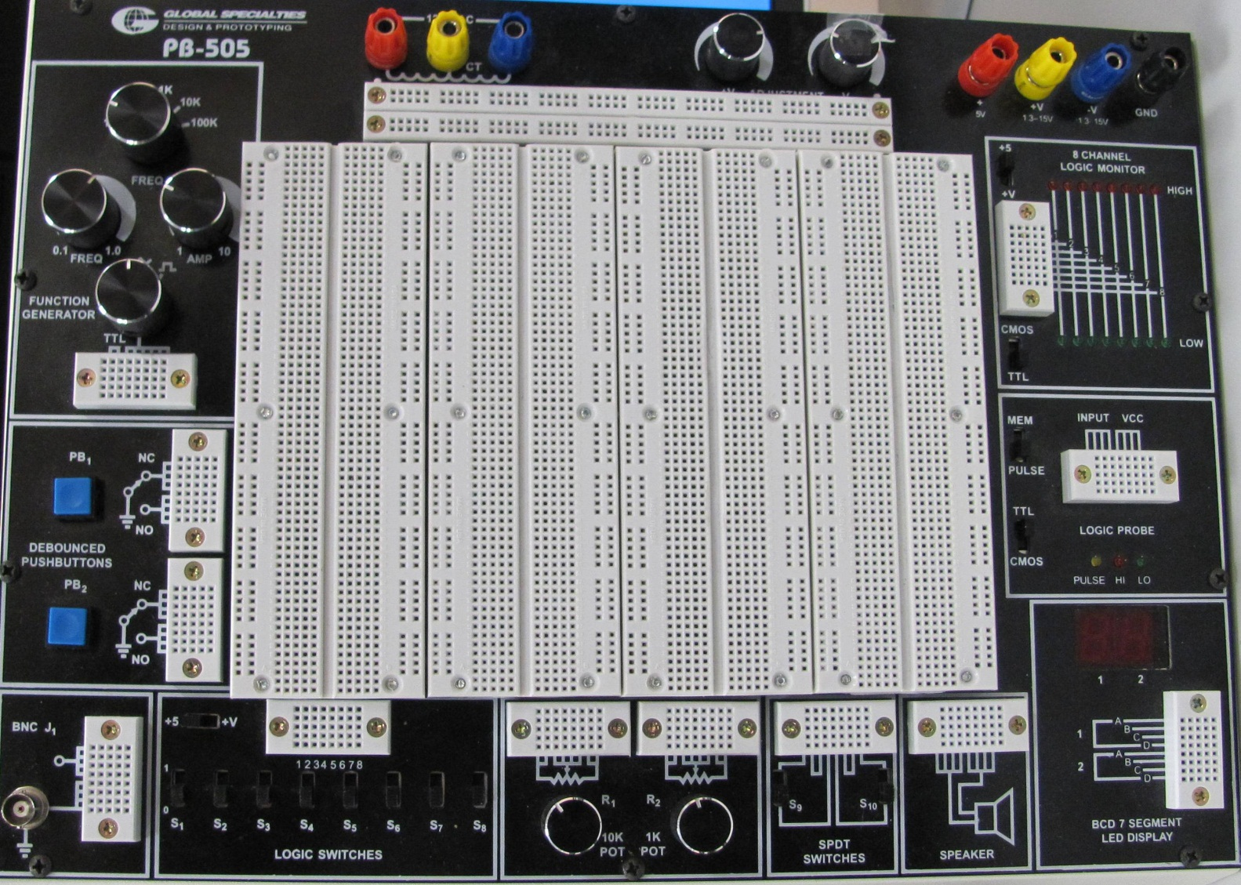

**Figure 1: PB 505 trainer board**

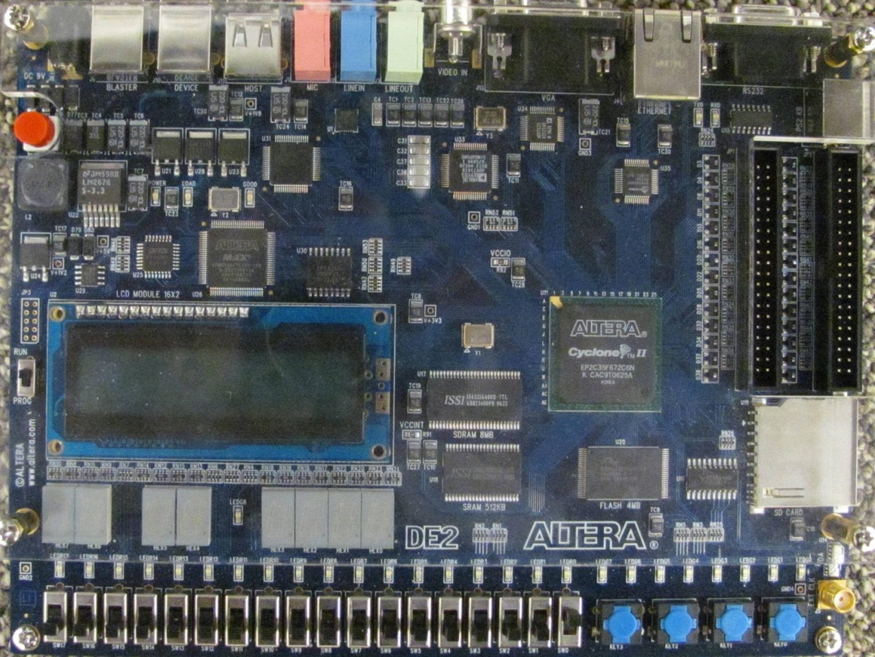

**Figure 2: ALTERA FPGA board**

Among all sections of PB 505 trainer board, what we are going to deal with are as follows:

1. **Power supplies**: The power supply is used to apply power to the ICs. Since we are going to work with TTL ICs, we need the Ground and +5V. The fixed 5V supply is required for the ICs using in this lab.
2. **Logic Indicators**: Sixteen LED's, eight red and eight green, make up eight Logic Indicators that will display logic high and low conditions. In this lab you should always select +5 and TTL. The red ones turn on when there is a high voltage, which means “true” or 1. The green ones turn on when there is a low voltage, which conversely means “false” or 0. An unconnected input, or an input not at a valid logic level, will cause both LED's to be off.



1. **Logic Switches**: By using these switches you can apply logic 1 or logic 0 to the input pins of an IC. The selector must be on +5.



1. **The Breadboards**: The breadboard allows you to connect components and wire your circuits very easily and quickly. The breadboard consists of many holes for you to connect hook-up wires and IC chips. Also, the leads or terminals of most of the components like [resistors](http://www.ldrengineering.org/resistors/), diodes, transistors, etc. can be pushed straight into the holes.

As you see in Figure 3 All of the holes are already connected together in groups. This way, you can connect two wires together (or connect a wire to an IC pin) simply by plugging the two wires into two holes that are already connected together. The holes in rows are linked horizontally and column holes are linked vertically.

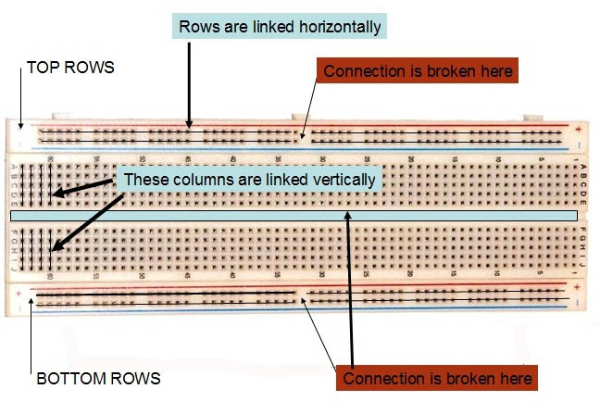

**Figure 3: Breadboard internal connections**.

<http://www.ldrengineering.org/building-a-circuit-on-breadboard/>

In addition to your PC and trainer boards, you will see some other devices for each station. These are instruments that can be either input or output for our boards. Now, we introduce them briefly so that you know when you may need them

1. Generating input voltages: Figure 4 shows the DC voltage supply and Figure 5 shows the AC function generator. They are inputs to our circuits.

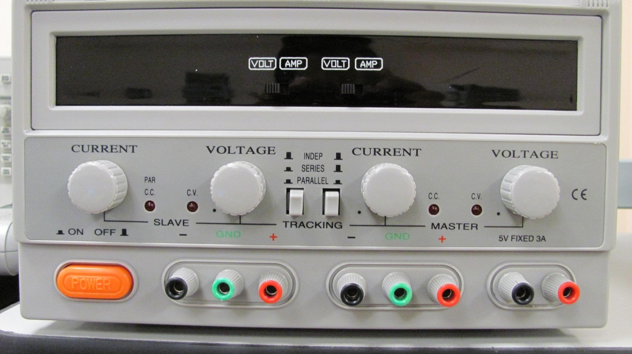

**Figure 4: DC power supply**

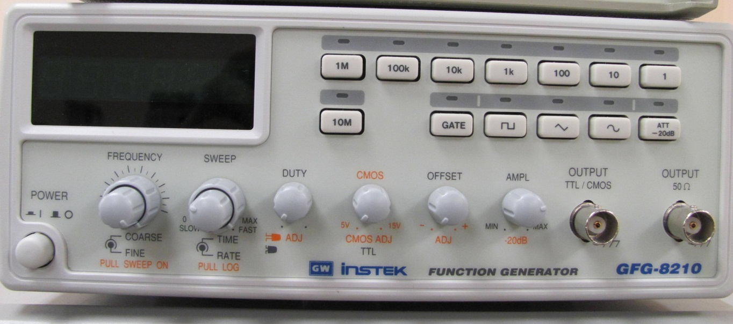

**Figure 5: Function generator**

1. Watching output voltages: Figure 6 shows a Multimeter used to determine the value of DC signals or effective value of AC signals. A Mutimeter allows you to measure the voltage of a signal. However, if we are interested in observing the timing details of a signal, we should use an oscilloscope, as seen in Figure 7. An oscilloscope can display a signal voltage as a function of time.

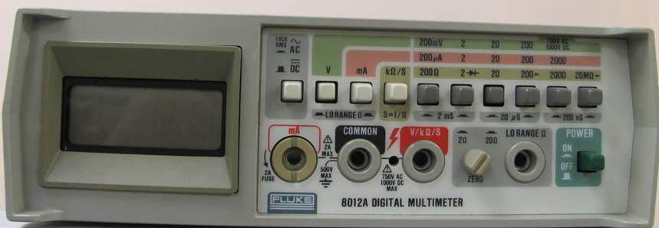

**Figure 6: Multimeter**

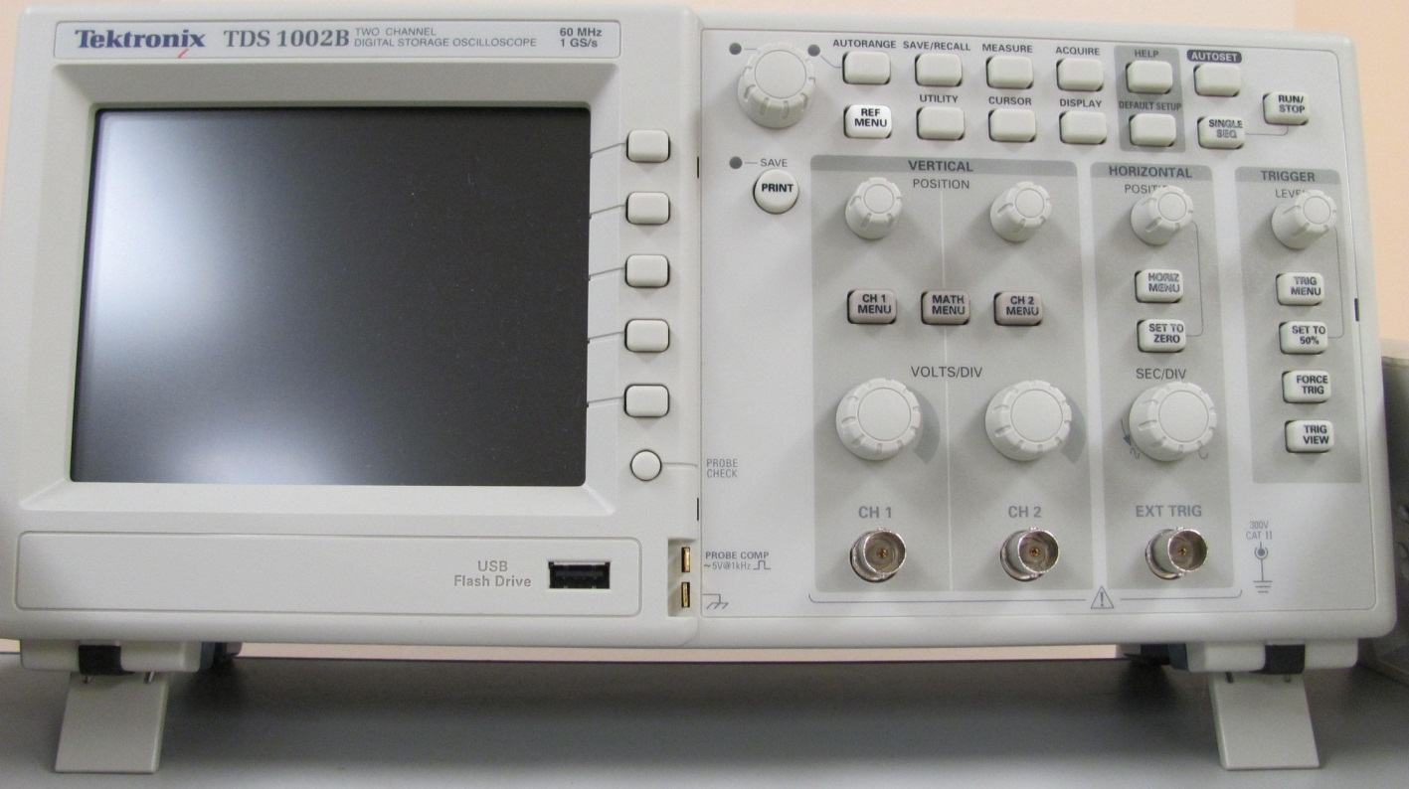

**Figure 7: Oscilloscope**

The 74XX family of TTL ICs includes basic gates such as AND, OR, NAND, NOR, and XOR. They vary in number of gates as well as the input numbers for each gate within them. Table 1 shows some of the part numbers and their contents.

|  |  |  |  |
| --- | --- | --- | --- |
| **Part number** |  |  | **Description** |
| 7400 |  |  | quad 2-input [NAND gate](http://en.wikipedia.org/wiki/NAND_gate) |
| 7402 |  |  | quad 2-input [NOR](http://en.wikipedia.org/wiki/NOR) gate |
| 7404 |  |  | hex [inverter](http://en.wikipedia.org/wiki/Inverter_(logic_gate)) |
| 7405 |  |  | hex inverter with open collector outputs |
| 7408 |  |  | quad 2-input [AND gate](http://en.wikipedia.org/wiki/AND_gate) |
| 7410 |  |  | triple 3-input NAND gate |
| 7411 |  |  | triple 3-input AND gate |

**Table 1: Some of 74 series ICs.(** [**http://en.wikipedia.org/wiki/7400_series**](http://en.wikipedia.org/wiki/7400_series)**)**

Figure 8 shows a 7404 TTL integrated circuit. The IC has a marker on one end so you can determine the correct orientation. Every IC needs to be supplied with appropriate voltage in order to work properly.

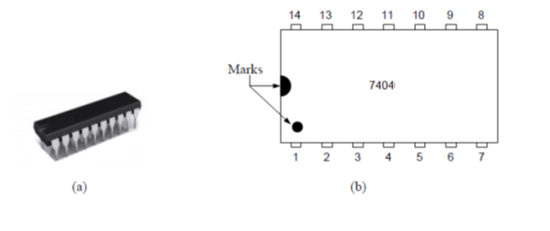

**Figure 8: 7404 IC**

As you see in Figure 9, pin 7 should be connected to GND and pin 14 should be connected to +5V. The other pins serve as inputs or outputs of the 6 invert gates.

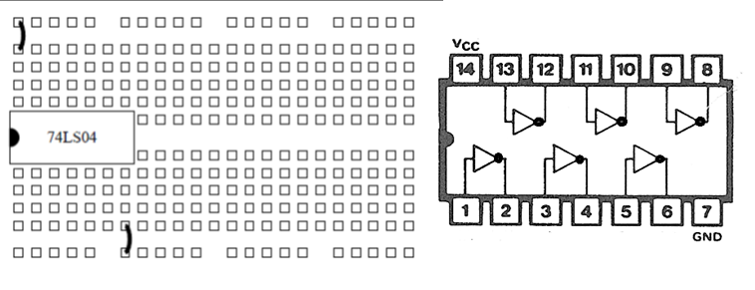

**Figure 9: 7404 IC pin out**

Some general rules of circuit construction are provided here to help you efficiently complete laboratory assignments.  
 1. Be careful when inserting ICs into the breadboard sockets. If you do not put it in straight, it is very easy to crush the pin into a zigzag shape or fold the pins underneath the body of the IC. This will lead to a bad connection or no connection at all, and possibly destroy the chip.

2. Every once in a while try to touch some metal objects to discharge yourself of static electricity before handing ICs.

3. Pay attention to the power and ground connections on the IC. Reversing these connections will destroy the IC. Shorting power and ground may damage the power supply by overheating it. Never apply a voltage above 5 volts to a TTL IC, it may damage the IC.

4. Always turn off the power when making connections, and turn it on only after you have finished making all of the connections.

5. ICs might feel slightly warm when working. However, if it is hot to the touch, turn off the power immediately and try to figure out what is wrong. If after inspecting your circuit you still cannot find the problem, notify the lab TA.

6. If a circuit fails to function, first check the power pins. Then use a multimeter to find the problem. You can start by checking the wires and then checking the voltages of IC pins. Sometimes this can be tedious, but it is worth it! If you construct your circuit neatly from the very beginning, it will help you a lot if debugging is needed.

7. After you are done, please put every piece in its place; remember your friend may use this lab right after you, and of course they do not want to waste their time searching through your mess to find what they need.

8. Lab reports are due one week after the lab session unless otherwise instructed. No late lab reports are accepted.

**Lab Problems:**

1. Connect a wire between input switch 1 (SW1) and output LED 1 (L1), SW2 and L2, and SW3 and L3. That’s 3 switches to 3 LEDs. Record the state of the LED for each data switch in the 1 position and 0 position.
2. **Important:** When connecting the power and ground wires to the IC chip make sure you are connecting them to the right pins! You can search on Google pin connections of a chip.

Find and place ONE [7404 IC (hex inverter)](http://www.ehobbycorner.com/images/logic_7404.gif) in the breadboard as instructed. The hex inverter has 6 (hex) NOT gates. Use the existing inputs from problem 1 (SW1, SW2, SW3) to connect to the inputs of 3 NOT gates inside the hex inverter. Their outputs should go to 3 LEDs (same as Problem #1).   
  
Again, Record the state of the LED for each data switch in the 1 position and 0 position.

Please write the truth table for each gate as you test them (they should look like Figure 10).

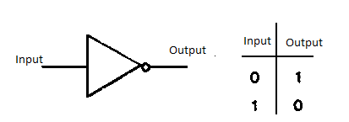

**Figure 10: Truth table of an inverter (NOT) gate**

1. Remove the wiring for SW2, SW3, and the corresponding LED wiring they were hooked up to. This leaves you with SW1->hex inverter->LED1. Using the same IC chip (hex inverter), build a circuit that cascades 3 of its gates. That is, SW1->NOT gate->NOT gate->NOT gate->LED. Write the truth table for this circuit by applying logic 0 and then logic 1. Also, draw this circuit in your lab report. **Why is the output the same as step 2? Include your answer on your report.**
2. Now find and test a [7408 IC](http://www.makeyourownchip.com/7408diagram.gif) that has AND gates. The AND gate has two inputs, rather than one like the HEX inverter. You will need to wire two switches (e.g. SW1 and SW2) to the inputs of one AND gate, and its output goes directly to the LED for the logic value. Write the truth table for your tests. **NOTE: You should test 2 AND gates in one 7408 chip**
3. Repeat step 5 for a 7432 IC that has OR gates. Write the truth tables for your tests. **NOTE: You should test 2 OR gates in one 7432 chip**
4. Write down the truth table for a NAND. If you were given an AND gate and a NOT gate, how would wire them up to make the same logic function as a NAND gate? **Include your answer in your report and the truth table for a NAND gate.**  
   Optionally: wire your circuit on your board to verify.